***ANNEX II + III:* TECHNICAL SPECIFICATIONS + TECHNICAL OFFER**

**Contract title: Supply of stationery**

**Publication reference:** <**03/2023/AID012590/08/8**>

**p 1 /…**

**Columns 1-2 should be completed by the contracting authority Columns 3-4 should be completed by the tenderer**

**Column 5 is reserved for the evaluation committee**

Annex III - the contractor's technical offer

The tenderers are requested to complete the template on the next pages:

* Column 2 is completed by the contracting authority shows the required specifications (not to be modified by the tenderer),
* Column 3 is to be filled in by the tenderer and must detail what is offered (for example the words ‘compliant’ or ‘yes’ are not sufficient)
* Column 4 allows the tenderer to make comments on its proposed supply and to make eventual references to the documentation

The eventual documentation supplied should clearly indicate (highlight, mark) the models offered and the options included, if any, so that the evaluators can see the exact configuration. Offers that do not permit to identify precisely the models and the specifications may be rejected by the evaluation committee.

The offer must be clear enough to allow the evaluators to make an easy comparison between the requested specifications and the offered specifications.

**Financial/technical offer**

**NAME OF THE SUPPLIER:**

**2021.1**

c4f_annexiitechspeciiitechoffer_en.doc

Page 1 of 23

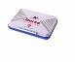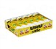

**2021.1**

c4f_annexiitechspeciiitechoffer_en.doc

Page 2 of 23

**Pos.**

**Description of Items**

**Technical specifications required**

**Preferred Unit Measure**

**Unit Measure offered by Supplier**

**Type of packaging**

**(box, ream, pack, bag, single piece...)**

**Quantity contained in each packaging-unit**

**Financial offer for packaging-unit (FRW)**

**Unit cost with delivery DDP**

**1**

UHU stick

BOX 12 PCS

**2**

Correction pen

1 Piece

**3**

Hole Puncher – Large

1 Piece

**4**

PVC box file big

1 Piece

**5**

2 Rings slim 16 mm

1 Piece

**6**

Pad (for stamp)

1 Piece



**2021.1**

c4f_annexiitechspeciiitechoffer_en.doc

Page 3 of 23

**7**

Ink for Pad

Kit Bottle 4 color

**8**

Stapler machine

1 Piece

**9**

Staples Pins 24/6

Box 10 x 1000 pcs

**10**

Stapler Big

1 Piece

**11**

Staples Pins 23/15

Box 10 x 1000 pcs

**12**

Pin Remover

1 Piece

**13**

**PEN WITH 4 COLOR**

1 Piece

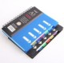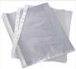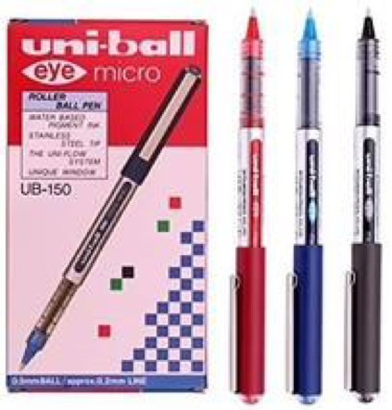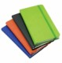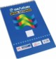

**2021.1**

c4f_annexiitechspeciiitechoffer_en.doc

Page 4 of 23

**14**

**Uni-Ball Pen**

Packet of 12pcs

**15**

A5 notbook with divider

1 Piece

**16**

A4 Plastic Sheets Protectors

Package 100 pcs

**17**

Note book A5 with elastic

1 Piece

**18**

Note book A4

Box of 6 pcs

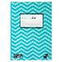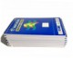

**2021.1**

c4f_annexiitechspeciiitechoffer_en.doc

Page 5 of 23

**19**

Note Book A5

Box of 12 pcs

**20**

Staple gun

Piece

**21**

Exercise Book 50 sheets 50 page

Piece

**22**

Scientific Calculator

1 Piece

**23**

Eletronic Calculator

1 Piece

**24**

Battery Size AA 1,5V

Packet 4 pcs

**25**

Battery Size AAA 1,5V

Packet 4 pcs

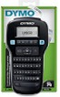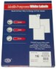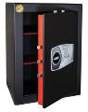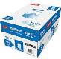

**2021.1**

c4f_annexiitechspeciiitechoffer_en.doc

Page 6 of 23

**26**

Button Cell Battery – 20 mm

Piece

**27**

Multi porpose white label A4 100 Sheets

Piece

**28**

adhesive label maker

Piece

**29**

Strongbox

Piece

**30**

Carton of paper A4

5 ream x 500 paper

**31**

Highlighting pen

Box 4 pcs

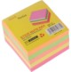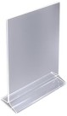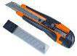

**2021.1**

c4f_annexiitechspeciiitechoffer_en.doc

Page 7 of 23

**32**

White envelope A4

Packet/25 pcs

**33**

WHITE ENVELOPE A5

Packet/25 pcs

**34**

Table top display

1 Piece

**35**

Cutter with blade

1 Piece

**36**

Scissors – Large

1 Piece

**37**

Sticky Notes 3x3 cm

1 Packet

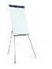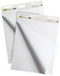

**2021.1**

c4f_annexiitechspeciiitechoffer_en.doc

Page 8 of 23

**38**

Sticky Notes 3x5 cm

1 Packet

**39**

Block of Receipts

1 Piece

**40**

Pencil with Eraser HB

Box 12 pcs

**41**

Rubber

1 Piece

**42**

Flip Chart tripoid type 70x100cm

1 Piece

**43**

Paper for flip chart

1 Piece

**44**

Flip chart board mobile with wheels

1 Piece

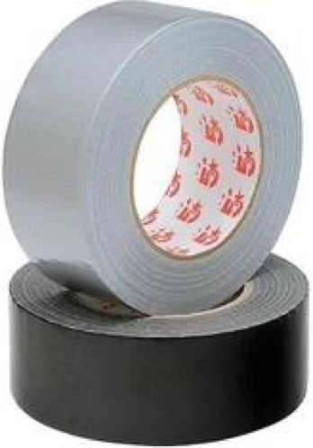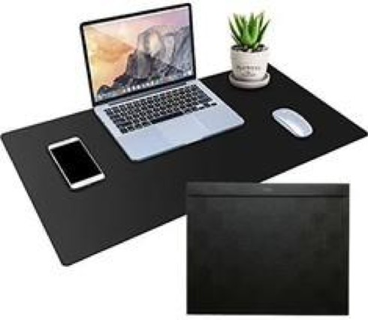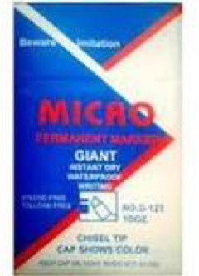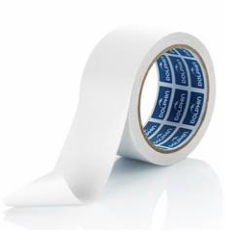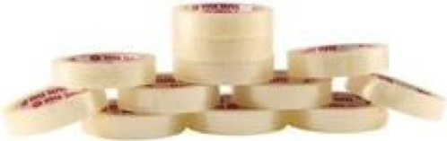

**2021.1**

c4f_annexiitechspeciiitechoffer_en.doc

Page 9 of 23

**45**

PVC Desk Blotter 58 x 45 cm

1Piece

**46**

Permanent marker snowman

Box 12 pcs

**47**

Erasable Marker for Witheboard – various colours

Box 12 pcs

**48**

Cello tape 12mm

Piece

**49**

Binding cloth tape medium size

1 Piece

**50**

Double side tape big size

1 Piece

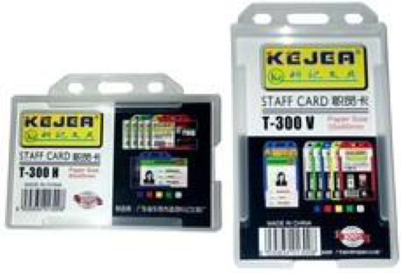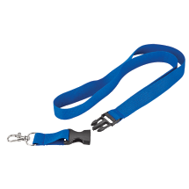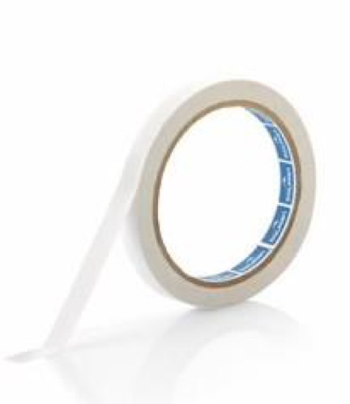

**2021.1**

c4f_annexiitechspeciiitechoffer_en.doc

Page 10 of 23

**51**

Double sided tape 12mm

1 Piece

**52**

Id card holder

Packet

**54**

Badge string Best quality

Packet/10 pieces

**55**

Paper clips 33 mm

Box of 100 pieces

**56**

Metal Tray 3 tire

1 Piece

**57**

Penholder

1 Piece

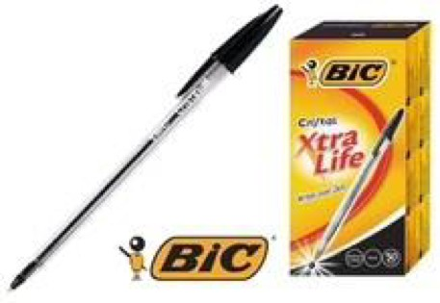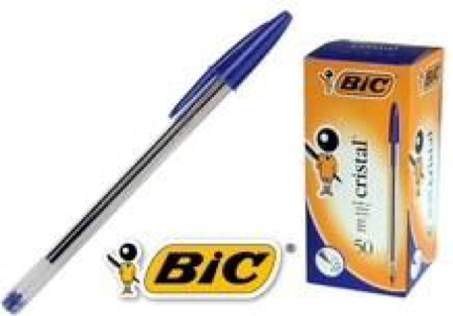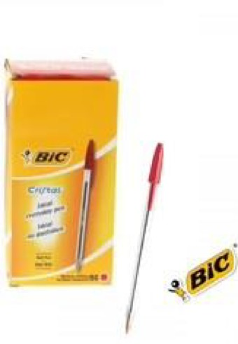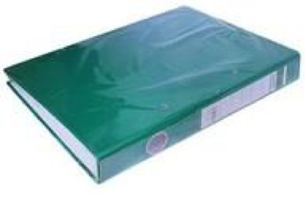

**2021.1**

c4f_annexiitechspeciiitechoffer_en.doc

Page 11 of 23

**58**

Metal sharper

1 Piece

**59**

2 Ring Slim 16mm

1 Piece

**60**

Magnetic witheboard 100x200cm

1 Piece

**61**

Stylon BIC pen Red box of 50 pcs

Box

**62**

Magnetic whiteboard duster Couche

1 Piece

**63**

Stylon | pen

Black box of 50 pcs

Box

**64**

Stylon | pen

Blue box of 50 pcs

Box



**2021.1**

c4f_annexiitechspeciiitechoffer_en.doc

Page 12 of 23

**65**

A4 Laser printer transparency film

Piece

**66**

Paper cutter (big one) A4, Metal

Piece

**67**

Plastic file folders with button

Piece

**68**

Plastic file folders

Piece

**69**

Plastic file folders with file fastener

Piece

**70**

Paper file folder

Piece

**71**

Notebooks A4/A5

Sinarline, spiral notebook A4

Piece

**72**

Adhesive labels

Piece

**73**

File holder

Piece



**2021.1**

c4f_annexiitechspeciiitechoffer_en.doc

Page 13 of 23

**74**

Binder clips 25mm

Piece

**75**

Paper clips 78MM

Piece

**76**

Clipboard Plastic

Piece

**77**

Stickers

Scotch, 140 flags

Piece

**78**

Rulers

Flexible ruler, 30cm for children

Piece

**79**

Rubber band

RUBBER BAND SMALL SIZE 50gr

Piece

**80**

Spiral binding rings

Size: 10mm

Piece

**81**

Spiral binding rings

Size: 12mm

Piece

**82**

Spiral binding rings

Size: 14mm

Piece

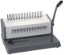

**2021.1**

c4f_annexiitechspeciiitechoffer_en.doc

Page 14 of 23

**83**

Spiral binding rings

Size: 25mm

Piece

**84**

Laminating pouches A4

Piece

**85**

ID card laminating pouches

Piece

**86**

Carbon paper

Piece

**87**

Rubber stamp Stamp on order

Proposal different size

**88**

Transparent sheets A4 for bookbinder machine

Piece

**89**

Manila sheets (100 per package) for bookbinder machine

Cardboard paper

Piece

**90**

Bookbinder machine for plastic spirals

Piece

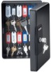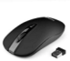

**2021.1**

c4f_annexiitechspeciiitechoffer_en.doc

Page 15 of 23

**91**

Laminating machine Heavy duty, metal

Piece

**92**

UPS 700 VA

Piece

**93**

UPS 1200 VA

Piece

**94**

Wireless mouse

Piece

**95**

Key cabinet 48

Piece

**96**

Cash box 25x20x9 cm

Piece

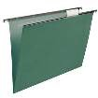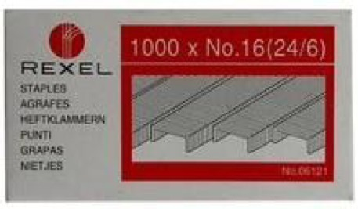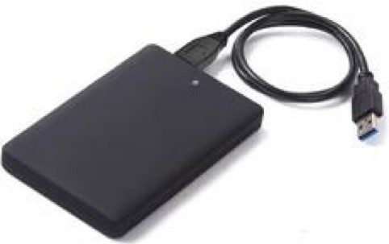

**2021.1**

c4f_annexiitechspeciiitechoffer_en.doc

Page 16 of 23

**97**

Cards wallet

Piece

**98**

Lables for key holder Officemate

Piece

**99**

Suspension files Target

Piece

**100**

foam clene

Pieces

**101**

STAPLES

Pieces

**102**

EXTERNAL HARD DISK

1tb

Pieces

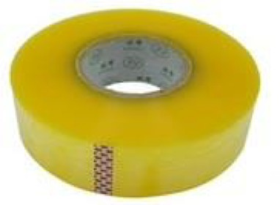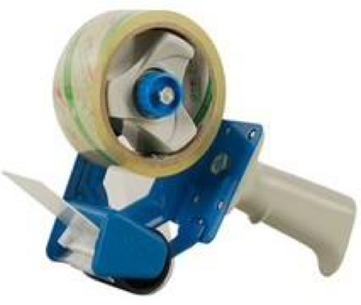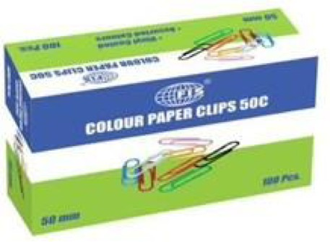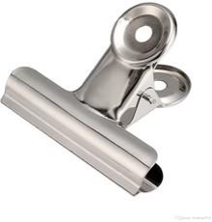

**2021.1**

c4f_annexiitechspeciiitechoffer_en.doc

Page 17 of 23

**103**

USB FLASH DRIVE

32gb

Pieces

**104**

Double sided tape 12mm 12 mm

Pieces

**105**

Packing tape - transparent 300m x 4.5cm

Pieces

**106**

Paper clips colored 50mm & 33mm 50mm

Pieces

**107**

Binder clips round 50mm

Pieces

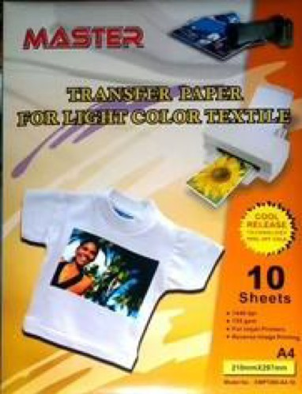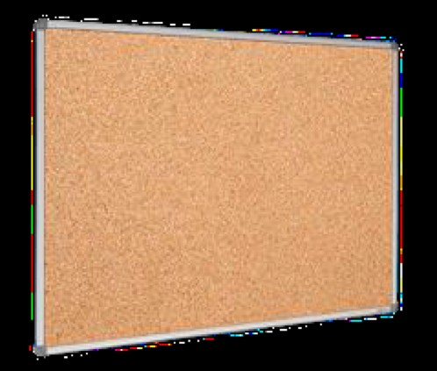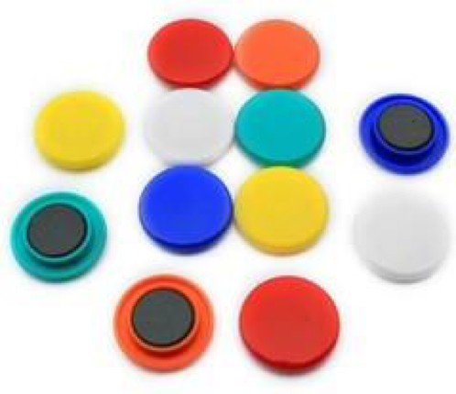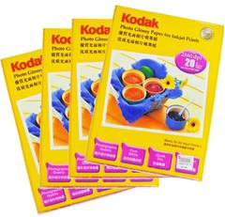

**2021.1**

c4f_annexiitechspeciiitechoffer_en.doc

Page 18 of 23

**108**

Transfer paper white / light

Package of 10 pcs

**109**

Photo paper A4

Package

**110**

Whiteboard magnet

Package

**111**

Cork Board 90 x 120 cm

90 x 60cm

Pieces

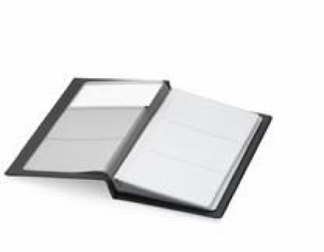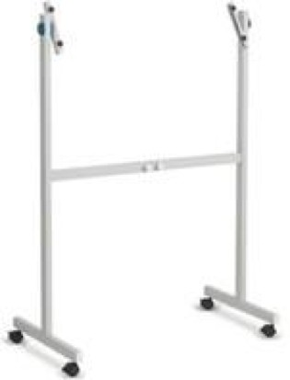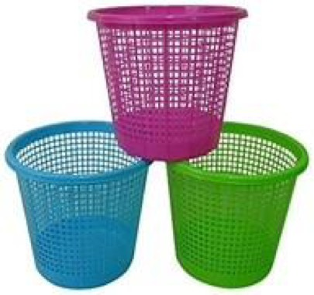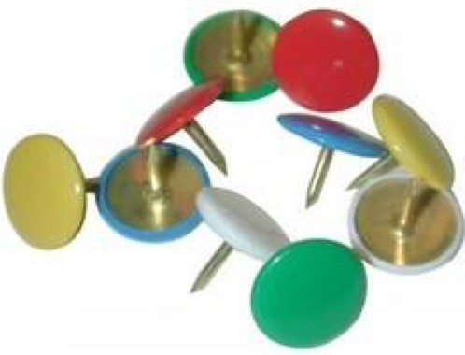

**2021.1**

c4f_annexiitechspeciiitechoffer_en.doc

Page 19 of 23

**112**

Adjustable whiteboard stand

Pieces

**113**

Plastic Dust bin

Pieces

**114**

Extension cable 5 ports

Pieces

**116**

Business card holder Business card holder 96

Pieces

**117**

Metal pin colour & thumb tack/

Pack

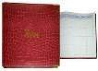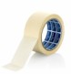

Done at:

by

**2021.1**

c4f_annexiitechspeciiitechoffer_en.doc

Page 20 of 23

**118**

Scissor | ciseaux Medium

Pieces

**119**

HP 85A Black Original LaserJet Toner Cartridge

Pieces

**120**

Complete ink set for Brother printer

Set multicolor

**121**

Masking tape 48mm

Pieces

**122**

Visitors Book

Pieces

*DELIVERY TIME FROM THE ORDER*

**Days**

**2**

*DELIVERY QUANTITY AT THE ORDER*

**%**

**100**

*VALIDITY OF THE QUOTATION*

**Days**

**365**

Stamp and signature

**2021.1**

c4f_annexiitechspeciiitechoffer_en.doc

Page 21 of 23

**2021.1**

c4f_annexiitechspeciiitechoffer_en.doc

Page 22 of 23

**2021.1**

c4f_annexiitechspeciiitechoffer_en.doc

Page 23 of 23